**Table 1**

*Means and standard deviations of absolute magnitude of AMP effects*

|  |  |  |  |
| --- | --- | --- | --- |
| **Experiment** | **Domain** | **Mean** | **SD** |
| 3 | Valence | 0.30 | 0.29 |
| 6 | Valence | 0.29 | 0.29 |
| 7 | Valence | 0.32 | 0.29 |
| 8 | Valence | 0.32 | 0.29 |

**Table 2**

*Means and standard deviations of absolute magnitude of IA-AMP effects*

|  |  |  |  |  |
| --- | --- | --- | --- | --- |
| **Experiment** | **Domain** | **Effect** | **Mean** | **SD** |
| 2 | Valence | IA-AMP Effect | 0.28 | 0.25 |
| 2 | Valence | IA-AMP Influenced Effect | 0.68 | 0.31 |
| 2 | Valence | IA-AMP Non-Influenced Effect | 0.20 | 0.24 |
| 3 | Valence | IA-AMP Effect | 0.36 | 0.29 |
| 3 | Valence | IA-AMP Influenced Effect | 0.67 | 0.31 |
| 3 | Valence | IA-AMP Non-Influenced Effect | 0.24 | 0.25 |
| 4 | Valence | IA-AMP Effect | 0.28 | 0.24 |
| 4 | Valence | IA-AMP Influenced Effect | 0.79 | 0.23 |
| 4 | Valence | IA-AMP Non-Influenced Effect | 0.20 | 0.23 |
| 5 | Valence | IA-AMP Effect | 0.30 | 0.29 |
| 5 | Valence | IA-AMP Influenced Effect | 0.73 | 0.31 |
| 5 | Valence | IA-AMP Non-Influenced Effect | 0.21 | 0.22 |
| 6 | Valence | IA-AMP Effect | 0.30 | 0.28 |
| 6 | Valence | IA-AMP Influenced Effect | 0.69 | 0.28 |
| 6 | Valence | IA-AMP Non-Influenced Effect | 0.22 | 0.27 |
| 7 | Valence | IA-AMP Effect | 0.32 | 0.27 |
| 7 | Valence | IA-AMP Influenced Effect | 0.62 | 0.31 |
| 7 | Valence | IA-AMP Non-Influenced Effect | 0.22 | 0.25 |
| 8 | Valence | IA-AMP Effect | 0.29 | 0.27 |
| 8 | Valence | IA-AMP Influenced Effect | 0.49 | 0.32 |
| 8 | Valence | IA-AMP Non-Influenced Effect | 0.20 | 0.22 |

**Table 3**

*Cooccurence of consistent and inconsistent prime-evaluation responses with trials registered as influence-aware and non-influence-aware.*

|  |  |  |  |
| --- | --- | --- | --- |
| **Experiment** | **Consistency of rating with prime** | **Influenced** | |
| 2 |  | **0** | **1** |
|  | **0** | 5672 | 1048 |
|  | **1** | 6670 | 4250 |
| 3 |  |  |  |
|  | **0** | 3389 | 923 |
|  | **1** | 4050 | 4310 |
| 4 |  |  |  |
|  | **0** | 3403 | 442 |
|  | **1** | 3772 | 2607 |
| 5 |  |  |  |
|  | **0** | 4859 | 667 |
|  | **1** | 5839 | 3539 |
| 6 |  |  |  |
|  | **0** | 6081 | 1115 |
|  | **1** | 7675 | 4929 |
| 7 |  |  |  |
|  | **0** | 3400 | 922 |
|  | **1** | 4097 | 2597 |
| 8 |  |  |  |
|  | **0** | 3336 | 1037 |
|  | **1** | 3919 | 2796 |

**Figure 1**

*Bimodality in the distribution of participants’ influence awareness rates in the IA-AMPs pooled across Experiments 2-8.*

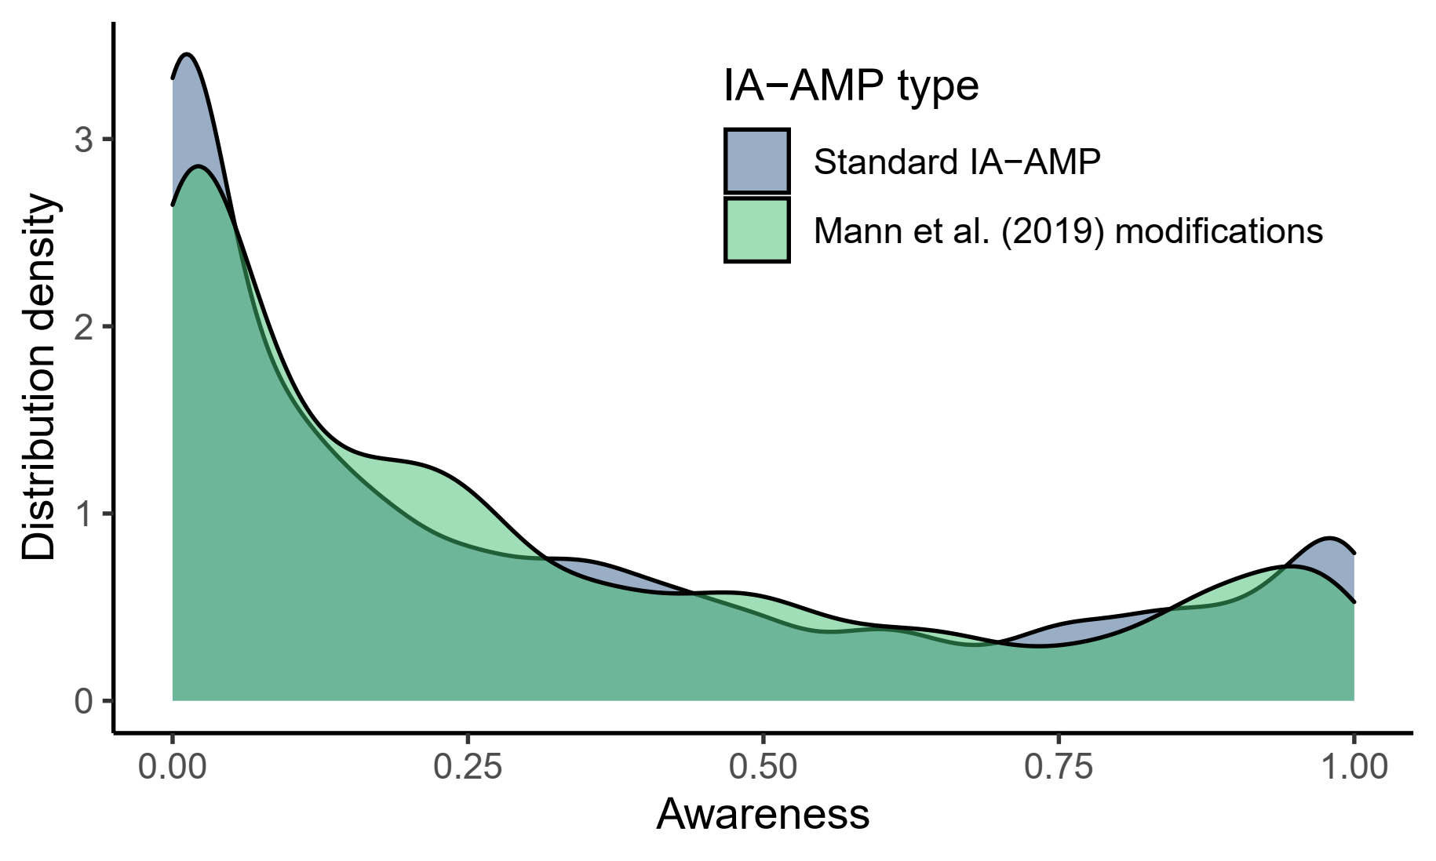

**Figure 2**

*The distribution of influence-awareness rates in the valence IA-AMP in Experiments 2-8.*

*.*